ODDELEK ZA FIZIKO FNM UM VABI NA PREDAVANJE

Liquid Crystals: living cells and flat screen TVs

Professor dr. Tim Sluckin

University of Southampton, UK

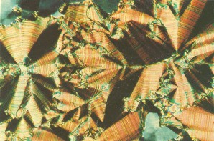
Liquid crystals are a peculiar state of matter. Discovered in the 1880s, for many years they were regarded merely as curiosities. The name is a misnomer, for crystals they are not, even though when they observed these materials under a microscope, 19th century scientists were persuaded that they were viewing exotic crystals. Nevertheless, these materials combine the fluidity of a liquid with some of the directional properties of a crystal. They display double refraction which can actively be controlled by application of external stimuli (eg voltages, magnetic fields or stresses).
Focal conic texture of a smectic liquid crystal seen between crossed polarisers

Nowadays liquid crystals are the heart of a multi-billion-pound business. They provide the core of the LCD displays found in the flat screens of many computers, mobile phones, e-book readers and more recently 3D TVs. But there are also a good number of increasingly important non-display applications. A non-exhaustive list includes: detectors for homeland security and medical diagnosis, light-shutters, optical switches, tuneable lenses, and even ultra-strong materials from liquid crystal polymers.

In this talk, I shall give brief description of the physics of liquid crystals. I shall mention also theoretical methods for describing liquid crystals, experimental methods (particularly optical methods) used in determining their properties, and some of the problems encountered by engineers as they sought to construct a viable technology. I shall also discuss work involving myself and colleagues in Maribor concerned with novel liquid crystalline materials.

Predavanje (v angleškem jeziku) bo v ponedeljek 14. novembra 2011 ob 11h v predavalnici 0/46.2 Oddelka za fiziko, Fakultete za naravoslovje in matematiko Univerze v Mariboru, Koroška 160, 2000 Maribor

